Exercise 7.1.
Inverse element in the GF(P) field for addition and multiplication operations

Operations modulo a prime number define a field of integers of finite dimension.
With a given modulus P, the field can only contain numbers equal to the remainder of division by P: or integers from 0 to P-1; (0, 1, 2, …, P-1)

The divisor of a prime number P can only be 1 and P.
Examples of prime numbers 1, 3, 5, 7, 11, 13, 17, 19, 23, 29, 31, …

An example of an addition table modulo the prime number 7.
+ | 0 | 1 | 2 | 3 | 4 | 5 | 6
0 | 0 | 1 | 2 | 3 | 4 | 5 | 6
1 | 1 | 2 | 3 | 4 | 5 | 6 | 0
2 | 2 | 3 | 4 | 5 | 6 | 0 | 1
3 | 3 | 4 | 5 | 6 | 0 | 1 | 2
4 | 4 | 5 | 6 | 0 | 1 | 2 | 3
5 | 5 | 6 | 0 | 1 | 2 | 3 | 4
6 | 6 | 0 | 1 | 2 | 3 | 4 | 5

An example of a multiplication table modulo the prime number 5.
* | 0 | 1 | 2 | 3 | 4
0 | 0 | 0 | 0 | 0 | 0
1 | 0 | 1 | 2 | 3 | 4
2 | 0 | 2 | 4 | 1 | 3
3 | 0 | 3 | 1 | 4 | 2
4 | 0 | 4 | 3 | 2 | 1

Only addition and multiplication operations are defined over the field GF(P) (or F_{P}) of integers.

An example of performing a subtraction operation on the GF(5) field.

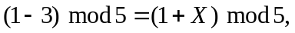
where X is the inverse of 3 mod 5.

X will be determined by the formula
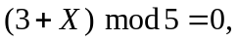
X is selected by direct search:
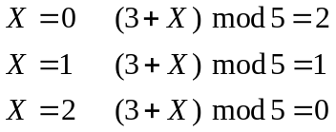
As a result we get

An example of performing a division operation in the GF(7) field
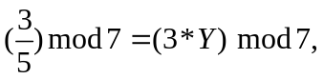
where Y is the inverse of 5 mod 7.
Y will be determined by the formula
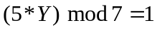
Y is selected by direct search:
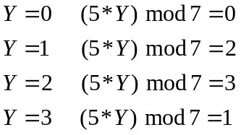

As a result we get
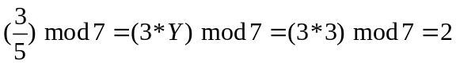

Exercise 7.1

Find the inverse element to B: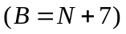:
1) for the addition operation in the field GF(P₁);
2) for multiplication operation in a field GF(P₂);.

Algorithm for performing point 1):
Let's denote 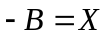, calculation formula 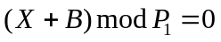.

Algorithm for performing point 2):
Let's denote 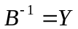, calculation formula 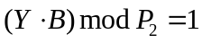.

Variant |  |  | Variant |  |  | Variant
N | P₁ | P₂ | N | P₁ | P₂ | N | P₁ | P₂
1 | 29 | 1187 | 10 | 67 | 1109 | 19 | 103 | 1051
2 | 31 | 1181 | 11 | 71 | 1103 | 20 | 107 | 1049
3 | 37 | 1171 | 12 | 73 | 1097 | 21 | 109 | 1039
4 | 41 | 1163 | 13 | 79 | 1093 | 22 | 113 | 1033
5 | 43 | 1153 | 14 | 83 | 1091 | 23 | 127 | 1031
6 | 47 | 1151 | 15 | 89 | 1087 | 24 | 131 | 1021
7 | 53 | 1129 | 16 | 97 | 1069 | 25 | 137 | 1019
8 | 59 | 1123 | 17 | 151 | 1063 | 26 | 139 | 1013
9 | 61 | 1117 | 18 | 101 | 1061 | 27 | 149 | 1009

